Setting Up Eclipse Development Environment on a Personal Computer
Setting up Development Environment

Need two things to write Java programs using Eclipse
- Java Runtime Environment (JDK)
  - Eclipse is a Java based IDE so 1st thing you need to do is install the JDK
- Eclipse
  - Eclipse is an integrated development environment used to create Java programs

Step 1: Download JDK (Java SE Development Kit)
- Google “JDK”
  - You should see the link- Java Downloads | Oracle
  - You could also enter:
https://www.oracle.com/technetwork/java/javase/downloads/index.html
- Click the Windows (or macOS) link under Java SE Development Kit (JDK 22) downloads
  - The kit number was 22 when these notes were created and may now be different but that is of no concern.

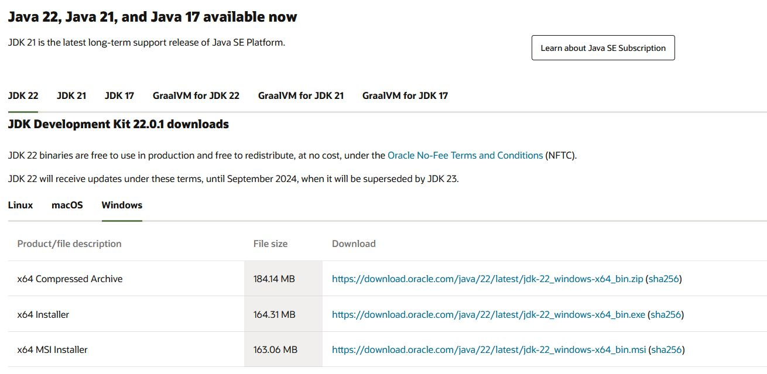

- Under Windows find the x64 Installer or under macOS find the x64 DMG Installer
- Click the .exe file link to download or for a Mac the .dmg file link
- If using Chrome, in the lower-left corner, you will see the download status
- If using Firefox, in the upper-right corner, you will see an arrow you can click on to see the download status
- The JDK’s executable file will download into the browser’s default download location
  - Default download location is the “downloads” folder in your “user” account
    - On my personal computer, this is C:\Users\Serena\Downloads
  - In Chrome or Edge, you can find where the download location is by:
    - Clicking the menu button (three horizontal or vertical dots) in the upper-right corner of the Chrome/Edge window
    - Select “Settings” from the menu
    - Settings will be displayed in a new tab
    - Select “Downloads” (left side of the page) and click it
  - If you prefer, you can set up your browser to ask where to save a download
    - Select “Ask where to save each file before downloading” to download to a directory of your choice.

Step 2: Install JDK
- Once the download completes, start the installation by double clicking on the downloaded .exe in the browser or in the directory it is saved in.
- You will be asked if you want to allow this app to make changes to your device - click Yes.
- Note: The installation can take a bit to get started – it can be slow - so be patient.
- In Windows, you will see the Welcome dialog – click Next to start download

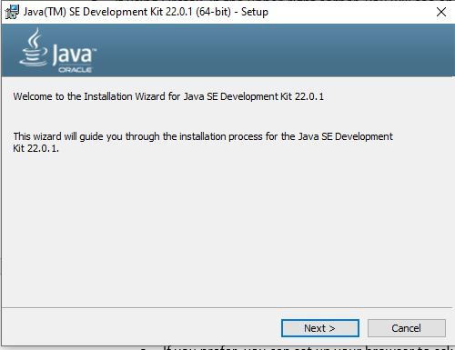
- The next dialog offers some options – click Next.
  - Notice that the JDK will be installed in the Program Files directory (for Mac it's the System - Library directory)
  - This is where it should be installed so don’t change the location

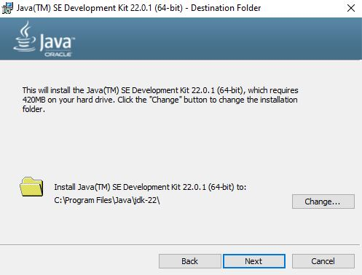

- A status window will start showing the installation status – be patient it takes time to get started
  - Note: Sometimes during the install, the status window appears but does not show any status . When this happened and I looked in the C:\Program Files directory (the location for the Java installation) I saw a Java directory and it contained the JDK files. I never saw any status but several minutes later I saw the successfully installed screen.

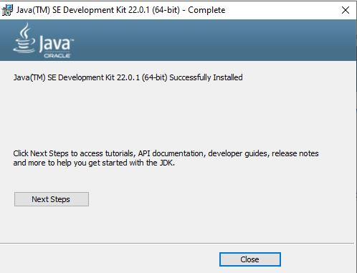

- You’re now set to use the JDK.

Step 3: Download Eclipse (When I installed it, the current version was: 2024-03 R)
- Go to: http://www.eclipse.org/downloads/packages/
- Scroll down to Eclipse IDE for Enterprise Java and Web Developers (DO NOT use the installer)
- Don’t worry if the version is different from 2024-03R.

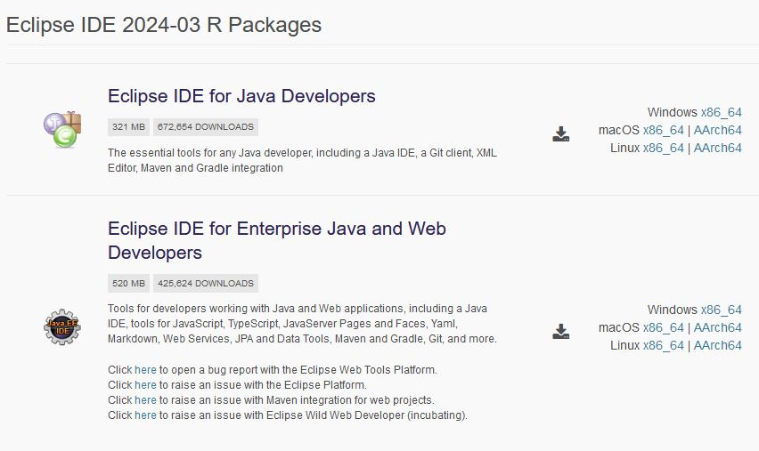

- On the right-hand side, click “Windows X86_64” (or “Mac OS X86_64”)
- You should end up on a page with a big download button - click that button!

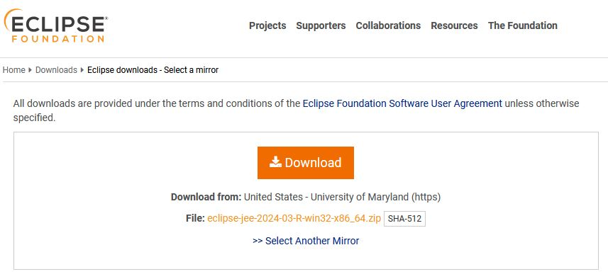

- The Eclipse zip file will download into the default download location (the “download” folder in your “user” account) unless you have set up your browser to save to a different location.
- You do not need to donate to the community.

Step 4: Extract the Eclipse files to a directory of your choice
- Eclipse is a bit different since you don’t actually “install” it.
- Instead, because it is a zip file you will extract it to a directory of your choice.
- Locate the eclipse zip file in the directory it was saved
  - If you don't know where that is, in Chrome, click the down arrow on the download then select “Show in folder.”

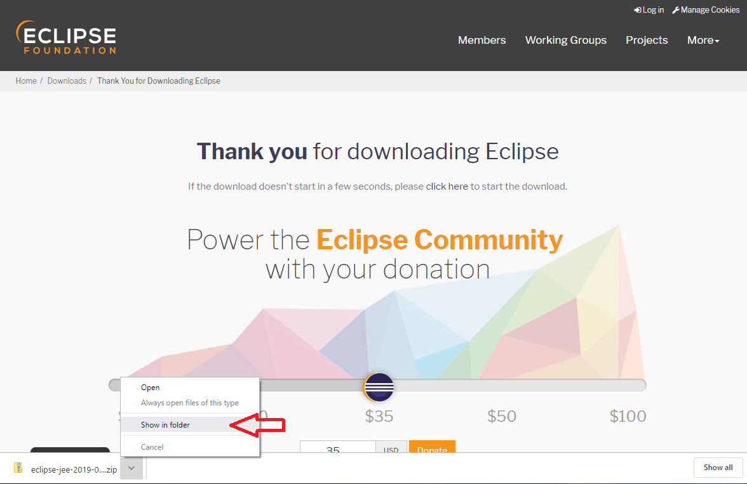

- Right click on the Eclipse zip file and select “Extract all”

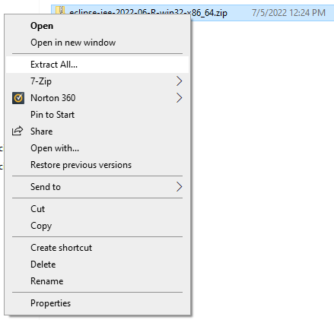

- The “Select a Destination and Extract Files” dialog will be displayed
- In the dialog, select where to place Eclipse – SEE NEXT bullet for some guidance on location

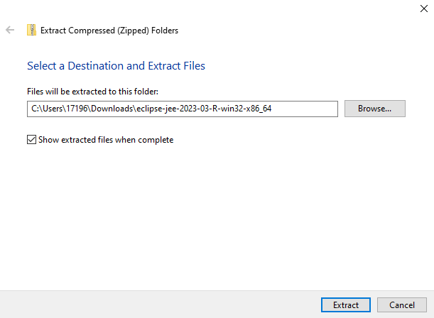

- On my personal systems, my preference is to create a "Dev" directory on my C drive and unzip Eclipse there - C:\Dev
  - When you start to do more development, having a development directory on your machine helps keep all development tools in one place.

- NOTE: Placing the eclipse file too deep into the file structure causes an error.

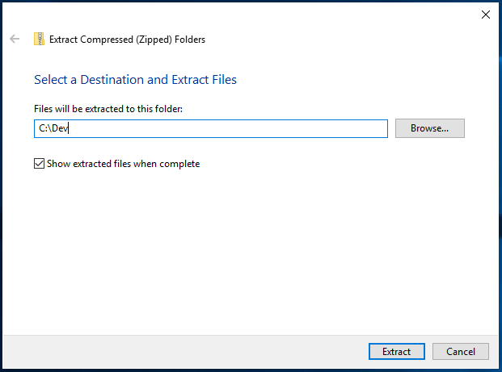

- The unzip will start – this could take a while depending on your system.
- When the unzip completes, go to the location you selected and view all the files
  - On my system that location is C:\Dev\eclipse

- Note: if you ever need to uninstall Eclipse, just delete the eclipse directory.
  - Note, when reinstalling or updating eclipse, make a backup copy of the eclipse workspace directory in case you run into issues! See step 6 regarding workspace directory.
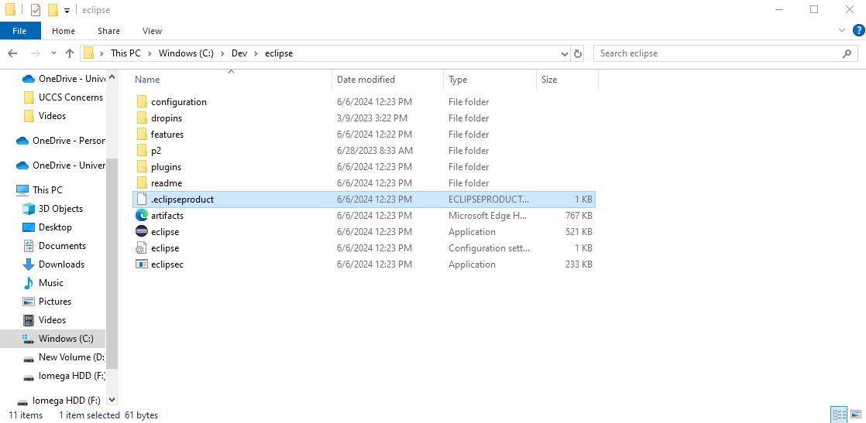

Step 5: Setup Environment Variables
- Find where the JDK is on your hard drive.
- It should be in the Program Files directory in the Java directory:

C: -> Program Files -> Java -> jdk-22

- Go one more level down to the bin directory

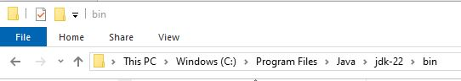

- In the File Explorer window, click in the little window where the path is shown which will highlight the path. Make sure the path includes the bin directory.

- Copy the path to the bin directory (since it's highlighted use CTRL-C to save it in the buffer)

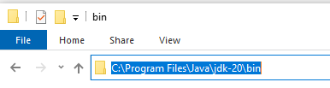
- In the File Explorer window, right click on "This PC"
- Select Properties from the menu

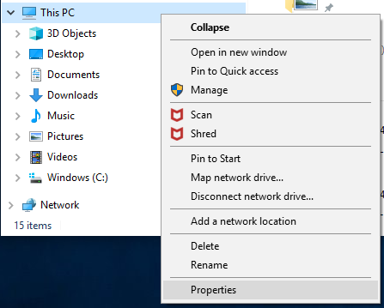

- A new window will appear showing your system information.
- On the right, scroll down to Related Settings and click “Advanced system settings”
  - Note if you have Windows 11, there is a link called “Advanced system settings”

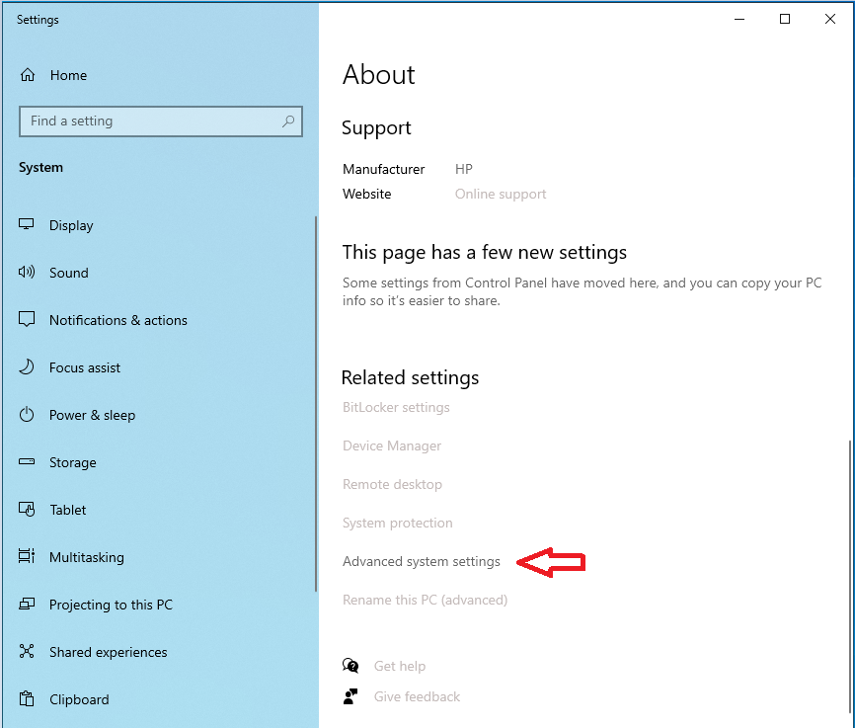

- In the System Properties window, click the “Environment Variables…” button

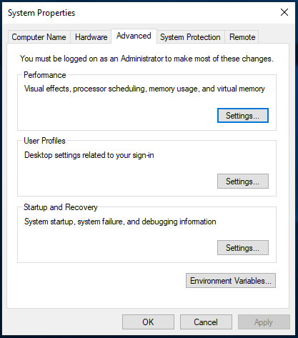

- The Environment Variables window will display.
- In the lower window - "System Variables" - find "Path" and single click on it to highlight

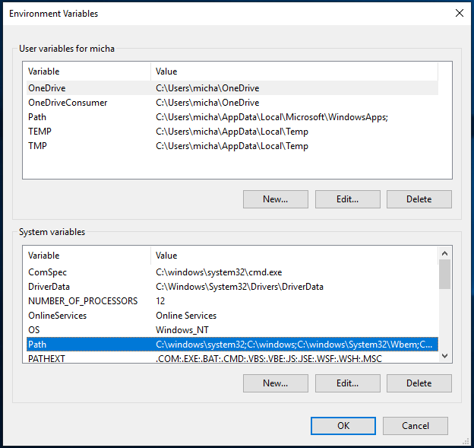

- Once "Path" is highlighted, click Edit and this window will appear.

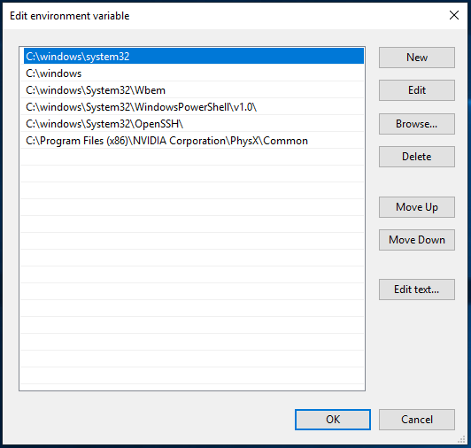

- Click New
- Paste the path for the JDK bin directory into the little window adding it to your path.
- Click on the little window
- Use CTRL-V to paste the path saved in the buffer into the little window

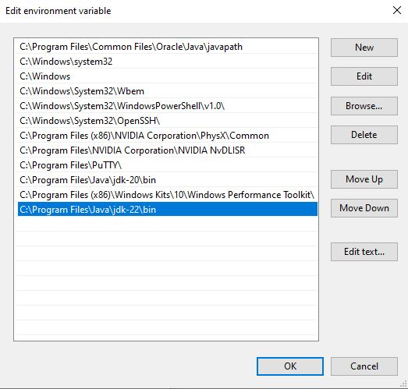

- Close all those windows by clicking OK

Step 6: Start Eclipse
- Go to the directory where you extracted Eclipse (on my system that would be c:\Dev\eclipse).
- Double click the eclipse.exe file
  - If you don’t see the .exe file extension – double click the file with the round purple icon
  - To see file extensions in file explorer, click “View” then check “File name extensions”



- Eclipse will ask where you want your workspace
  - A workspace is where the .java and .class files for your assignments will be stored.
  - On my system, the dialog shows the workspace directory in C:\Users\17196\eclipse-workspace

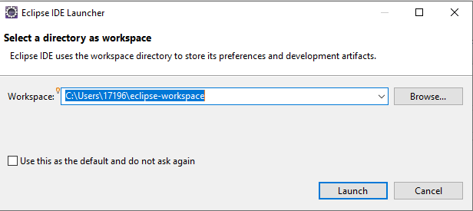

- Again, I like to change my workspace to use my “Dev” directory -- C:\Dev\eclipse_workspace

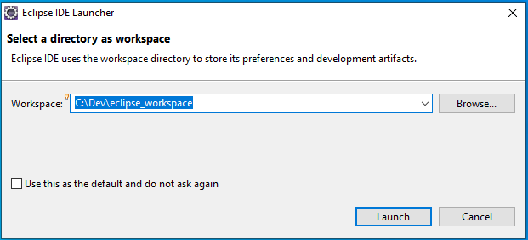

- Note: if you’re updating the version of Eclipse on your machine you will see the following dialog
  - Note: before you update Eclipse to a newer version make a backup copy of your current workspace in case you run into issues.

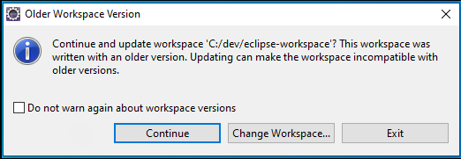

- The Welcome screen for Eclipse will appear. Click the Hide icon on the right side.

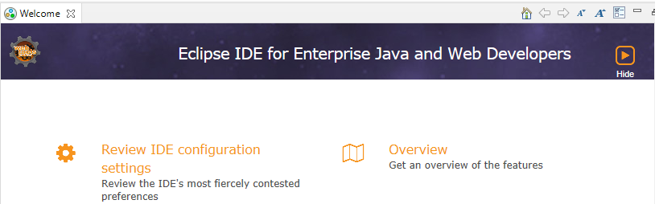

- Eclipse may now look like this:

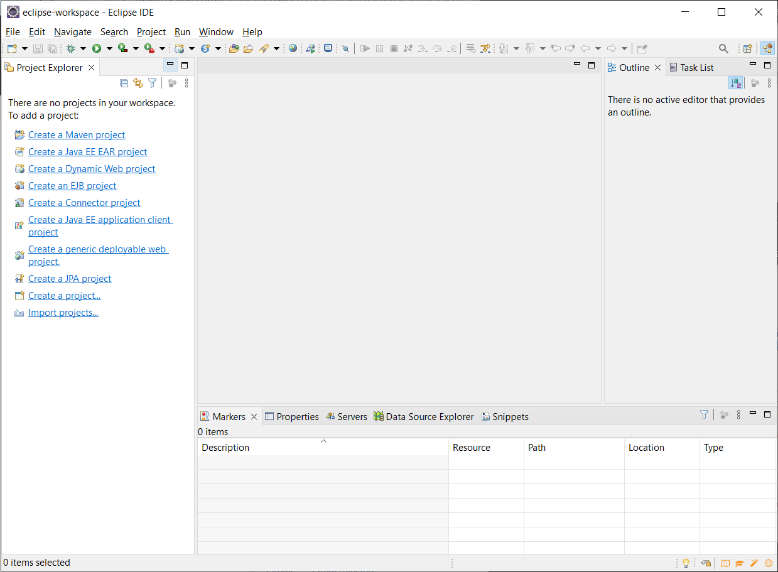

- At this point, on my computer system the “Dev” directory now contains 2 sub-directories:
  - eclipse
  - eclipse_workspace

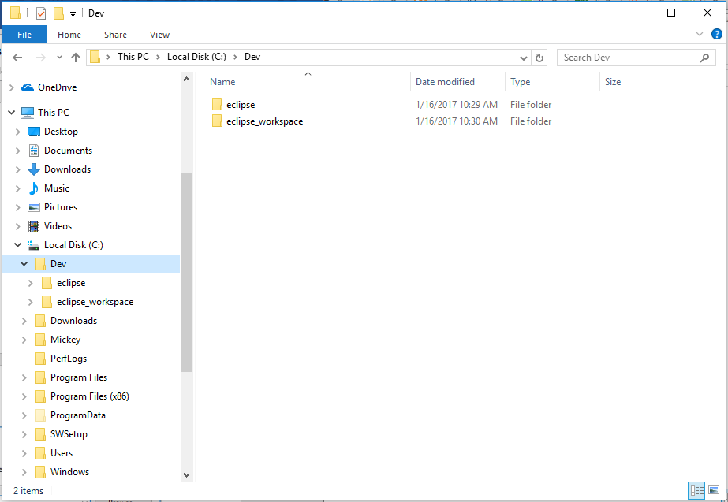

You are now setup to create, compile and run Java programs!

Creating a Java Program in Eclipse

Overview of programming in Java
- Type in source code using an editor
  - Create a .java file
  - This will contain what we call source code which is your Java code.
  - Eclipse is the editor - it automatically appends the .java to your source code files
- Compile source code
  - Compiling is done automatically in Eclipse
  - Compiling source code (.java) generates a .class file - .class file contains the bytecode
- Run the .class file
  - Running means to translate the bytecode into something that the platform understands
  - Bytecode is executed by the Java Virtual Machine (JVM)
  - The JVM then either compiles or interprets the bytecode

Steps for creating a simple Java program to get started
- Quick look at programming from a general view
- Everything will be covered in more detail in later lectures

1) Start Eclipse
2) Create a Java Project
- The first time you create a project you will see a little bit different menu than on future creations.
- On the top menu, select File->New-> Project to display the New project dialog

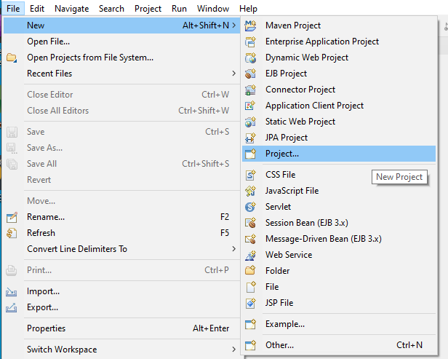

- In the New Project dialog that appears, select Java Project then click Next.

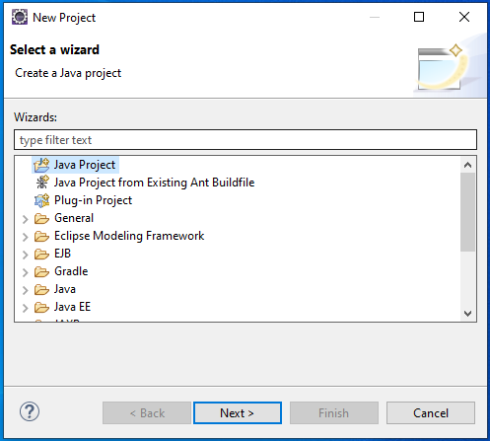

- Set the following in the Create Java Project dialog (shown on next page)
  - Project name
    - Give project a name - CS1150
    - All your programming assignments will be placed into this project folder
    - You only need one project folder for this class

  - Default location
    - Should be set to the workspace you selected when started Eclipse so nothing to change

  - JRE
    - This should be set the JRE installed on your system
    - Yours should show JavaSE-22, if not click the down arrow in the window and select JavaSE-19

  - Project Layout
    - Be sure to select - “Use project folder as root for sources and class files”
    - See the red arrow on the screen below

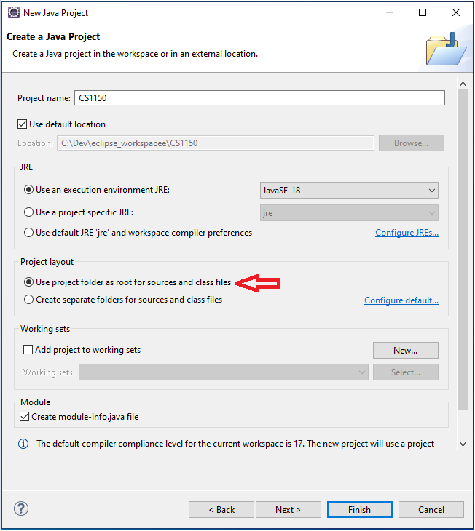

- Click "Finish" to create the project
- You may see the following dialog – click “OK”

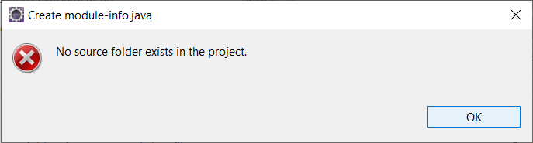

- You may also see a dialog that asks you about the Java perspective
  - Click “Open Perspective”

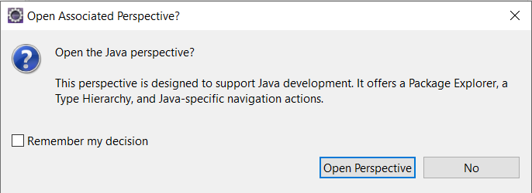

- If you go to your hard drive, in the workspace directory, you will now see the project CS1150
- You will create all programming assignments in this project (folder)

- IMPORTANT NOTE: before proceeding please read:
  - If there is a red ! next to the project name in Eclipse, your environment is NOT setup properly.

  - See the troubleshooting section at the end of this document for simple steps to fix this before you create a Java class. If you don’t resolve this issue, you will be unable to get your code to work.

3) Create a Java Class
- File->New->Class (or File->New->Other then pick Class in the dialog)

- Set the following (see screen below)
  - Source Folder – should be filled in with the name you gave your project - CS1150
  - Name - name for this assignment - LastNameFirstNameAssignment1
  - Which method stubs would you like to create?
    - Check: public static void main(String[] args)
    - Uncheck: Inherited abstract methods
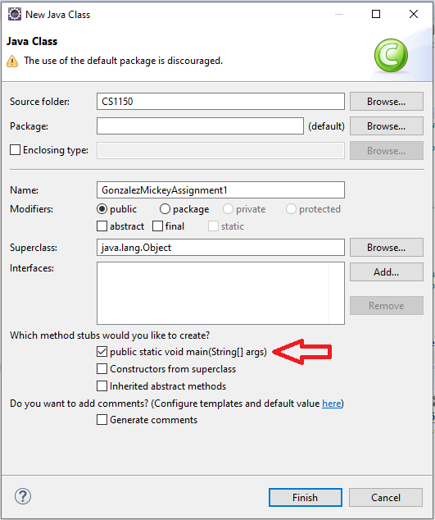

- Click Finish
- In Eclipse, on the left side you will see in the Package Explorer panel:
  - On the left:

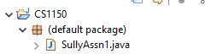

  - In the right editing window the code for source file GonzalezMickeyAssignment1.java

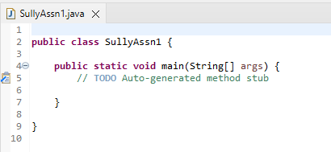

- You will repeat this step #3 (creating a java class) for each programming assignment.

- Note: if you go to your hard drive, in the workspace directory, open CS1150 and you will see two files in the CS1150 directory (C:\dev\eclipse_workspace)
  - SullyAssn1.class
  - SullyAssn1.java

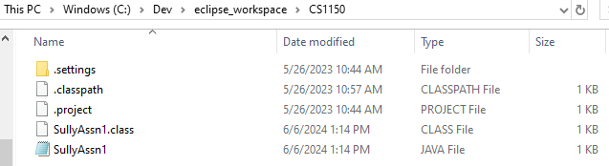

- Eclipse automatically built the .class file
  - In Eclipse, if you go under Projects, you will see “Build Automatically” is selected
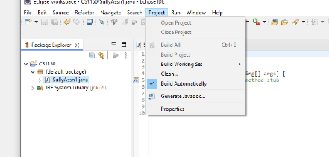
  - This is how the .class file was created automatically for you.

4) Add some code!
- Add the following line of code to “main”

System.out.println("Hello World");

- Place all code for Assignment #1 in the main method as shown below.

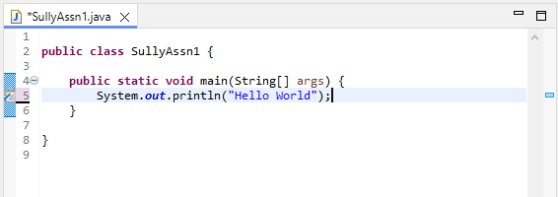

5) Compile and Run
- Two ways to run your code
  - Right click on Assignment1.java in left window, select "Run As" then “Java Application”
  - Select "Run" from the top menu

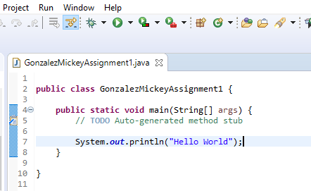

- If Save and Launch dialog appears, let’s set things up so you don’t see this dialog ever time you run the code.
    - Inside dialog, select the checkbox “Always save resources before launching”
- You should see the output in the console window on bottom of the screen

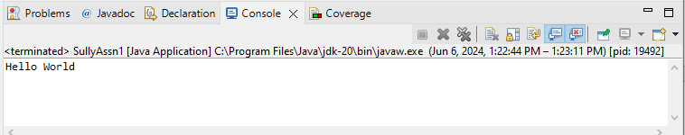

Eclipse Notes – A Few Tips
- To find information about Eclipse
  - Help -> Welcome
  - For tips and basic information click Overview then Workbench Basics
  - Click on Hide or Workbench to get back into eclipse
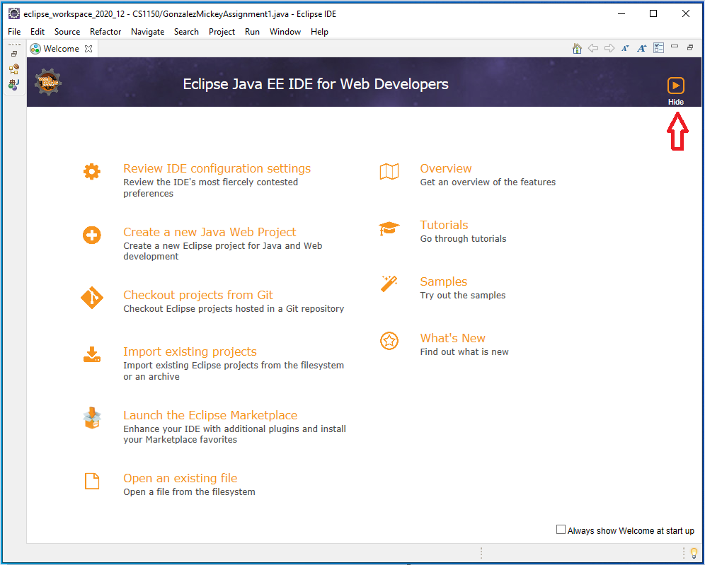

- Use the Java EE perspective
  - A “perspective” is just a layout of views.
  - A “perspective” controls what you see in certain menus and toolbar
  - If your “perspective” gets messed up
    - Window -> Perspective -> Reset Perspective…

- If lose a view, click on Window -> Show View
  - Clicking in a view makes it active

Troubleshooting Eclipse

This section covers two possible issues that you might run into
- Exit code 13 error
- Project has a red !

Issue #1: Exit code 13 error
- This error occurs when there is more than one version of the JRE on your system.

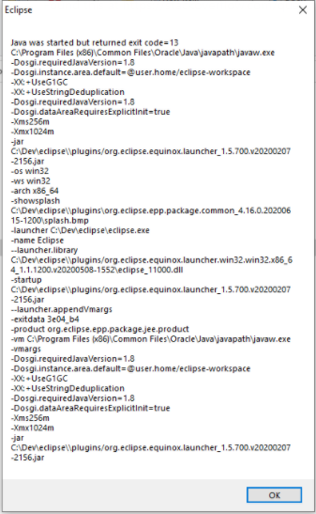

- Note that you have 2 directories on your C drive:
  - Program Files
  - Program Files (x86)

- You correctly installed the JDK into the Program Files
  - The Program Files directory is the correct location for the JDK so don’t mess with it.

- Exit code 13 occurs when there is a java directory in Program Files (X86)
  - If you have a Java directory in Program Files (x86), Eclipse will use it instead of the one you just installed in Program Files.
  - You need to UNINSTALL the java directory in Program Files (X86)
  - Uninstall is different from deleting, so DO NOT delete the directory.

- To fix this issue:
  - Uninstall the JRE in the Program Files (X86) directory
  - The new JDK that you just installed already contains the JRE.
  - Open the Control Panel
  - Select under Programs “Uninstall a program”

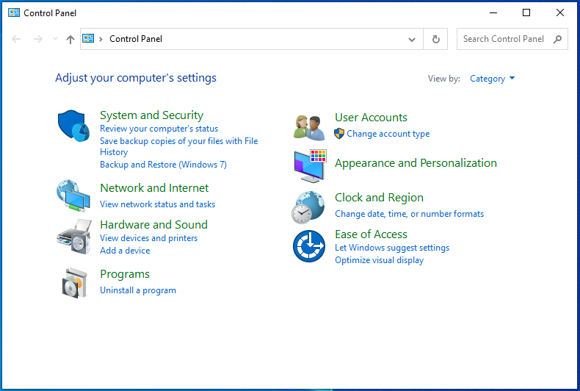
  - You next screen will appear with a list of all the programs installed on your system
    - Locate the JRE
    - I don’t have the JRE on my system so the screen grab only shows the JDK’s so I can’t show what this looks like.
    - Once you locate the JRE, select it, then select uninstall

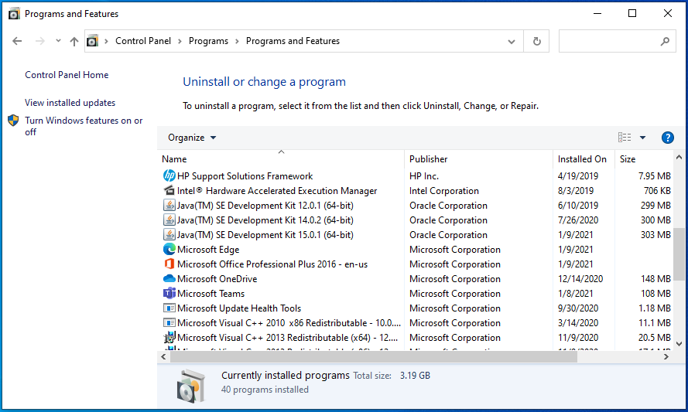

- You should now be able to start Eclipse.
- If not, send me in email a screen grab of any issue you are seeing.

Issue #2: Project has a red !
- A project with a red ! indicates that Eclipse needs to be told about the new JDK.
- Eclipse will not work properly until you fix this issue!

- In Eclipse, on the top menu, go to Window -> Preferences
- In the preference dialog, click arrow > next to Java to open Java, then select Installed JRE’s

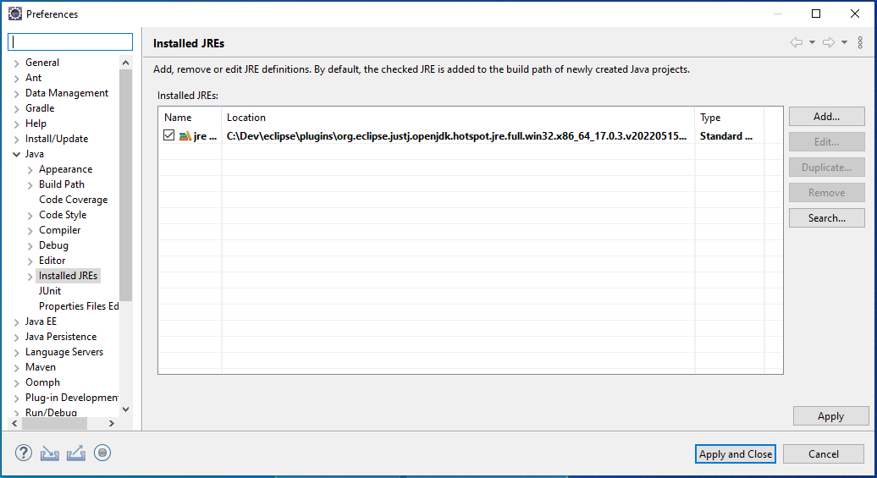

- Click Add
- In Add JRE window, select Standard VM then next

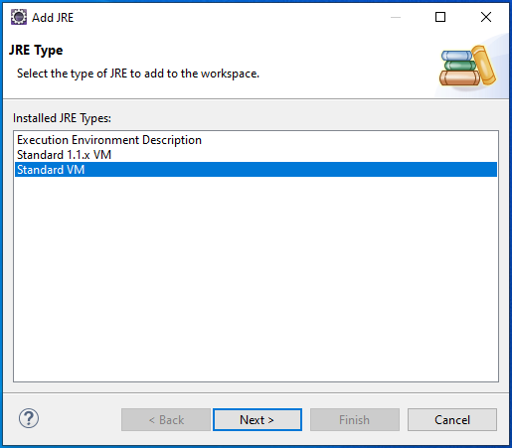

- In the updated Add JRE screen, to the right of JRE Home, click Directory...
- Browse to C:\Program Files\Java\jdk-22
- Highlight jdk-22 and click Select Folder

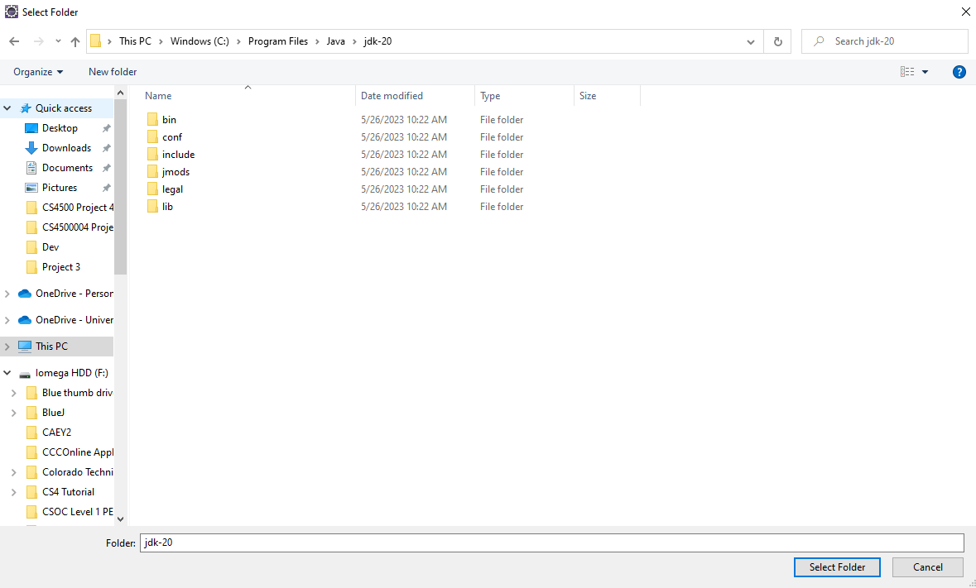

- The Add JRE dialog will now be filled in, click Finish

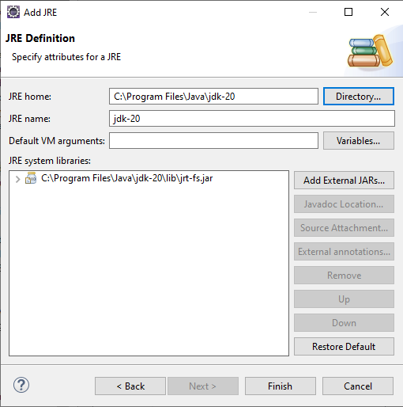

- You will now see in Installed JREs dialog a new entry with jdk-22
- Select the box to the left of the jdk-22

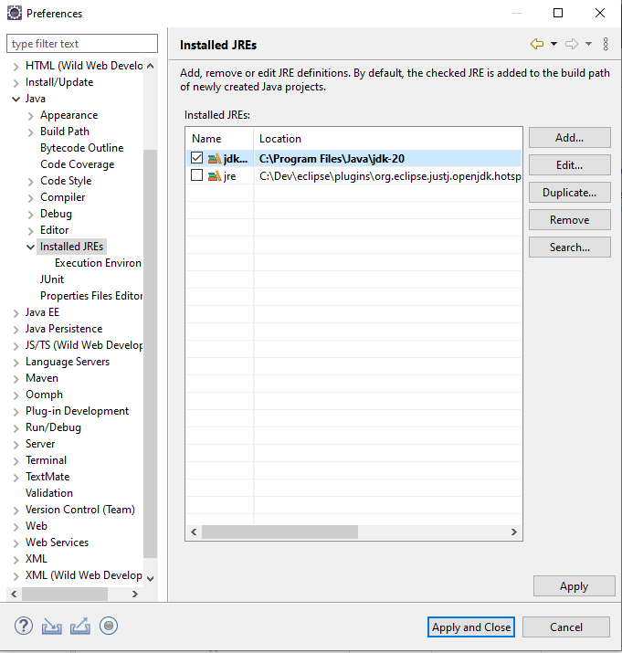

- Click Apply and Close button
- The CS1150 project should no long have the red !
  - If you still have an issue, send me an email.
- Return to Step 3: Create a Java Class on p.17
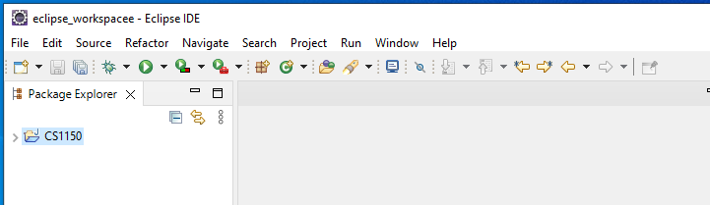
If you have an “Unbound classpath” error
- In Eclipse, go to Window -> Preferences.
- Under Java select "Installed JREs" and check one of the boxes to specify a default JRE. Click OK.
- Navigate to the folder’s properties (Right click on CS1150 and select Properties).
- Go to the "Java Build Path" section and choose the "Libraries" tab.
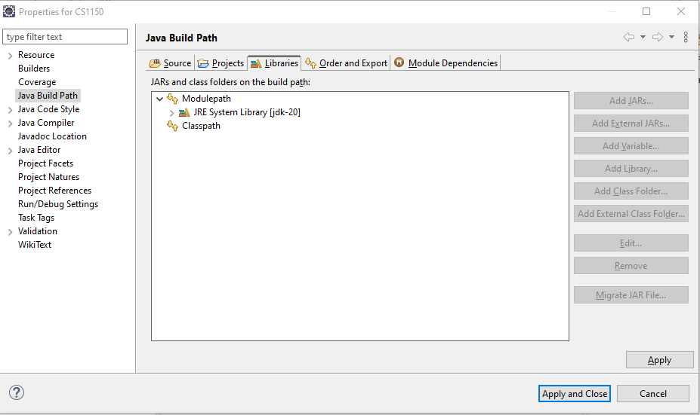
- Remove the unbound System Default library, by highlighting it and clicking on the Remove button on right.
- Click the "Add Library" button.
- Select "JRE System Library" and click Next.
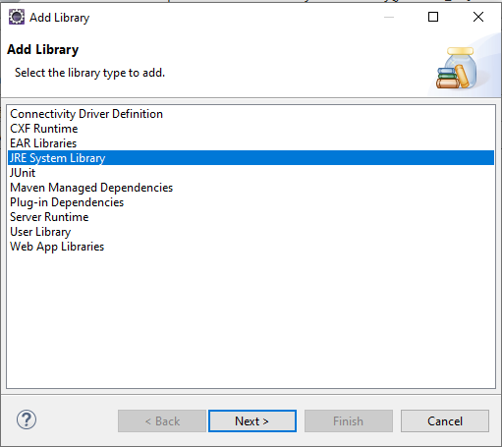

- Select Workspace default JRE (jdk-22) and click Finish

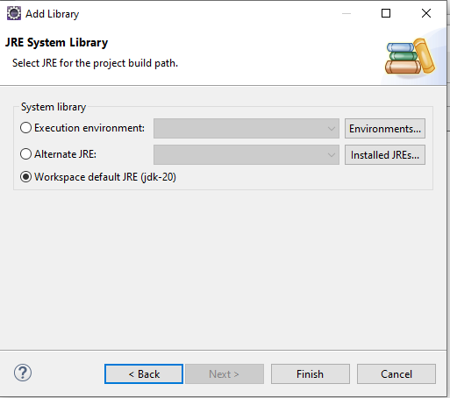

Note: What is Eclipse?
Eclipse is an open-source platform built on Java that enables software developers to create a tailored development environment using plug-in components developed by Eclipse community members. It is overseen by the Eclipse.org Consortium and is the most popular Integrated Development Environment (IDE) among Java developers. One of Eclipse's standout features is its plugin system, which allows users to add new functionalities as needed while ignoring any plugins they don't require.
Many operating systems use environment variables to convey configuration details to applications. Similar to properties in the Java platform, environment variables consist of key/value pairs, where both the key and the value are strings. The methods for setting and using these variables differ across operating systems and command line interpreters.

